**Creative SW Winter semester Project**

**20103316 Yunho Kim**

1. **Purpose**

Make the program & service with creative ideas based on winter semester for Creative Software Program.

1. **Summary**

Make the web site that shows subway cars crowdedness when user types specific station name and time.

* 1. Why I decide to make this program

When you take the subway, you will see most of passengers are standing nearby way out or transfer point within packed, but other cars don’t. If we make a crowdedness about this, passenger will find a quite cars and go there.

1. **Projects**

In this project, I will build the website about information for single subway line, and upload it

* 1. Data for this program

To service about subway cars crowdedness, I will use ‘Number of passengers in each hour’ and ‘Number of transfer passengers’ provides on Seoul Open Data Center. Also I research about location of way out in stations. It will be used for calculates density about passengers in platforms.

* 1. 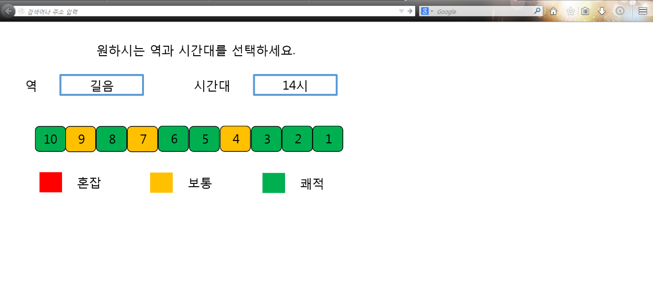Interface

(picture) The preview of Program

On website, user type the station and time in text box(or combo box). Based on this data, subway cars crowdedness will show to user to simple graphic of cars with colors.

Interface will be made by HTML5 + CSS3

* 1. Internal Algorithm

The internal code that calculate crowdedness will be made by Java. To service on web, I will use JSP and Tomcat for run the web server.

* 1. Etc.

Having enough time after if I will have built this program on Tomcat local server, use AWS and will run real website service.